1) Write a single ansible playbook which will install apache and nginx. Note: Playbook should not be hardcoded and pass the variables from different file.

Ansible Playbook to Install Apache and Nginx on Ubuntu (Using Variables)
This setup will:
- Install Apache and Nginx
- Use variables from separate files
- Avoid hardcoding package names
- Work on Ubuntu
- Step-by-step from scratch

Step 1: Install Ansible on Control Node
sudo apt update
sudo apt install ansible -y
Check version:
ansible –version
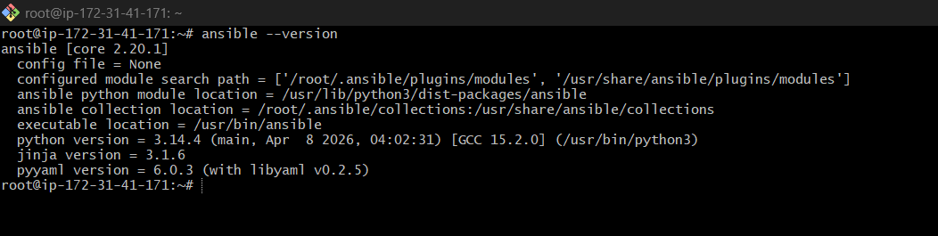

Step 2: Create Project Directory
mkdir webserver-playbook
cd webserver-playbook
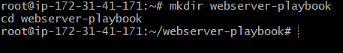

Step 3: Create Inventory File
Create hosts file:
nano hosts
Add:
[webservers]
172.31.40.75 ansible_user=ubuntu
Replace IP with your target Ubuntu server IP.
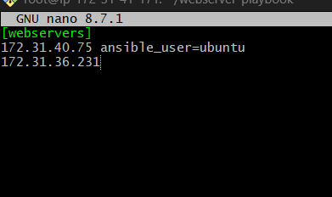

Step 4: Create Variable File
Create vars file:
mkdir vars
nano vars/packages.yml
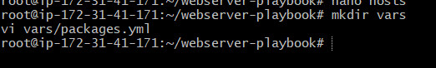
Add:
apache_package: apache2
nginx_package: nginx
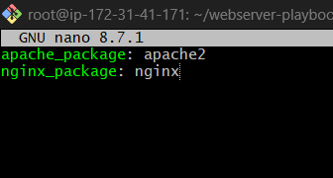

Step 5: Create Playbook
Create playbook:
nano install-webservers.yml
Add below playbook:
---
- name: Install Apache and Nginx
hosts: webservers
become: yes

vars_files:
- vars/packages.yml

tasks:

- name: Install Apache
apt:
name: "{{ apache_package }}"
state: present
update_cache: yes

- name: Install Nginx
apt:
name: "{{ nginx_package }}"
state: present
update_cache: yes

- name: Configure Nginx on Port 9000
copy:
dest: /etc/nginx/sites-available/default
content: |
server {
listen 9000 default_server;
listen [::]:9000 default_server;

root /var/www/html;

index index.html index.htm;

server_name _;

location / {
try_files $uri $uri/ =404;
}
}

- name: Restart Nginx
service:
name: nginx
state: restarted
enabled: yes

- name: Start Apache
service:
name: "{{ apache_package }}"
state: started
enabled: yes
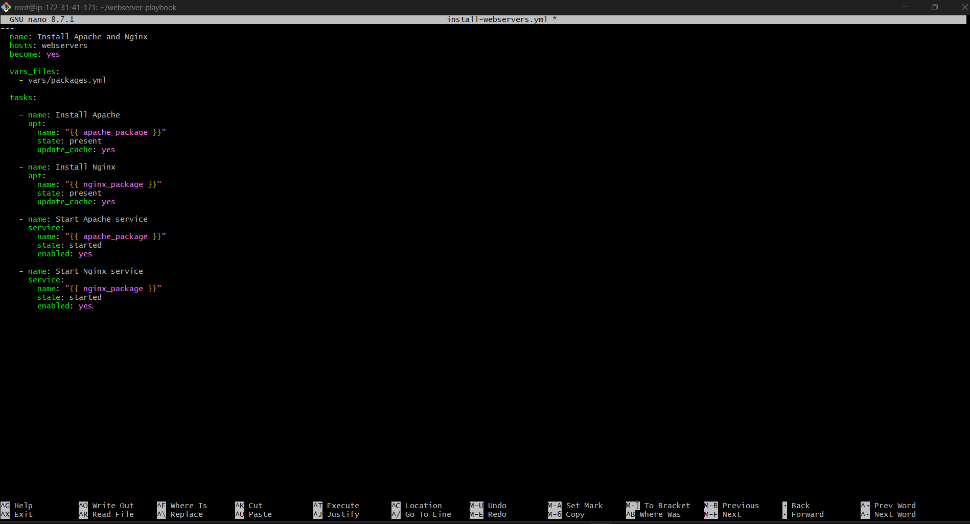

Step 6: Test Connectivity
ansible all -i hosts -m ping
Expected output:
SUCCESS
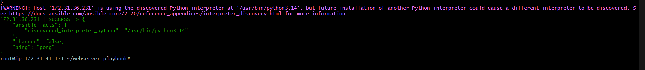

Step 7: Run Playbook
ansible-playbook -i hosts install-webservers.yml
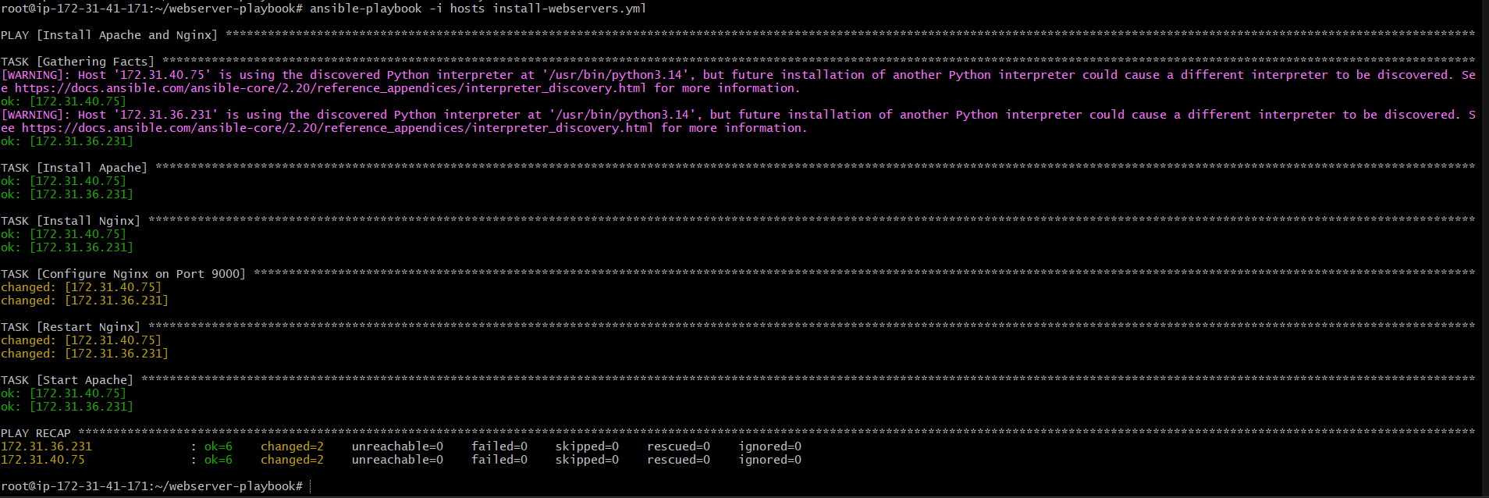

Step 8: Verify Installation
Check Apache:
systemctl status apache2
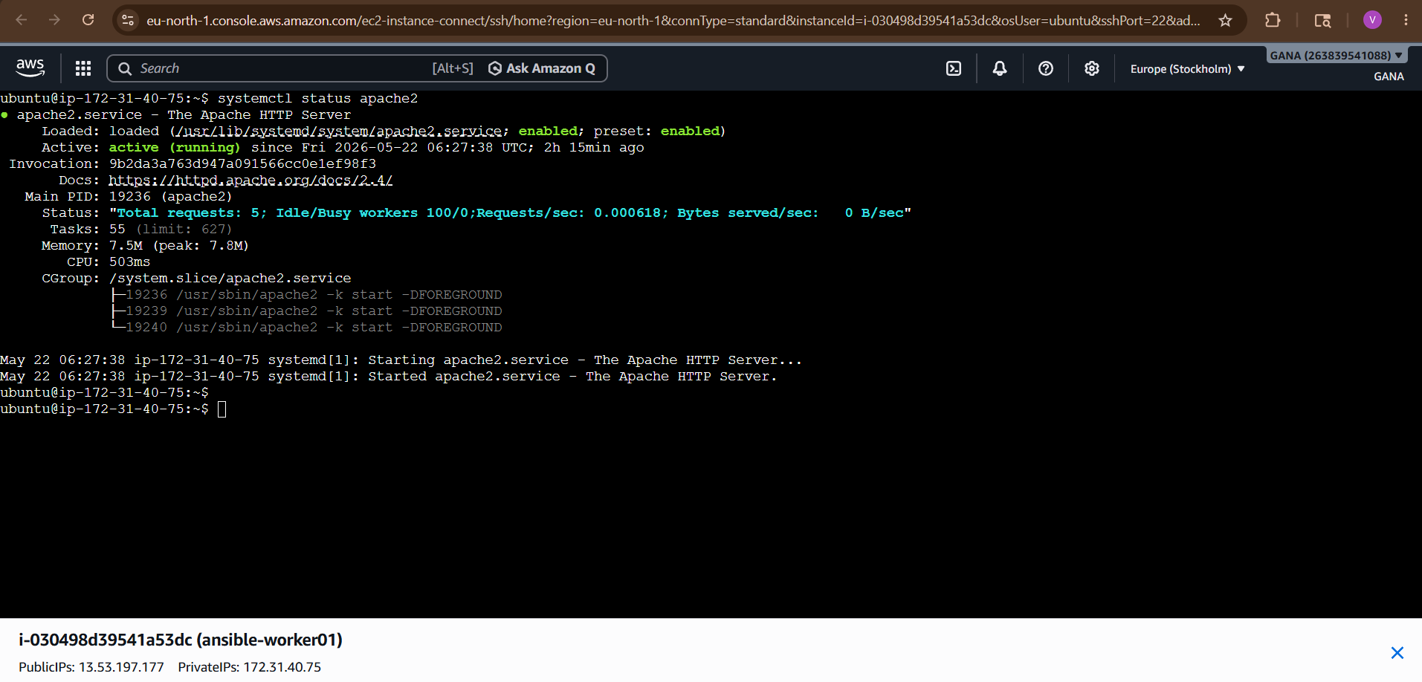
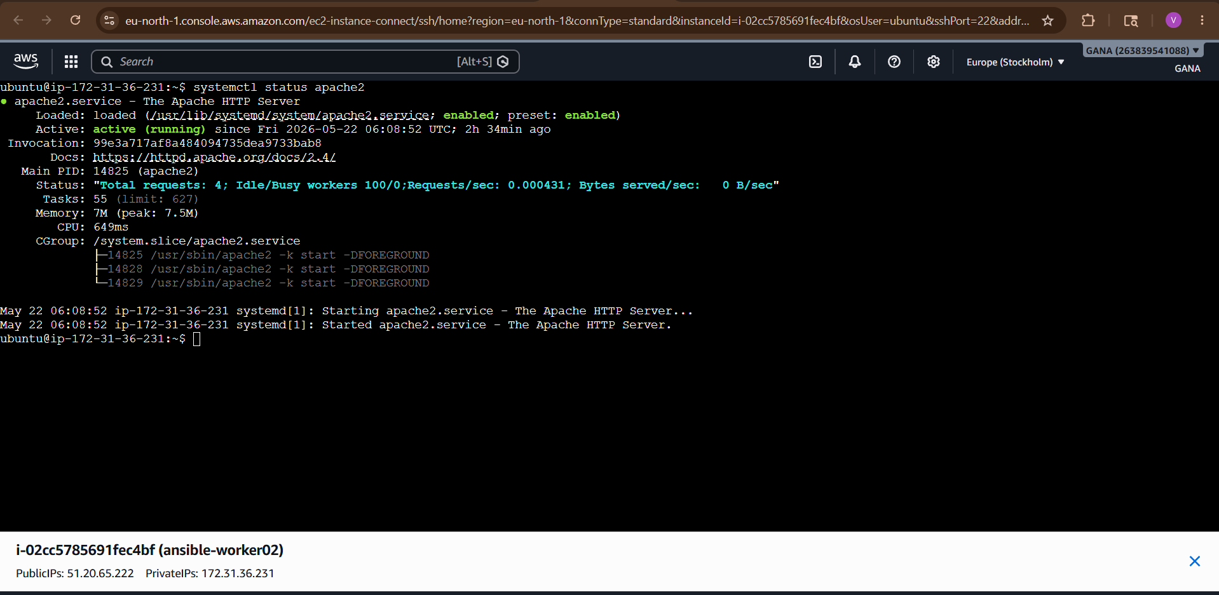
Check Nginx:
systemctl status nginx
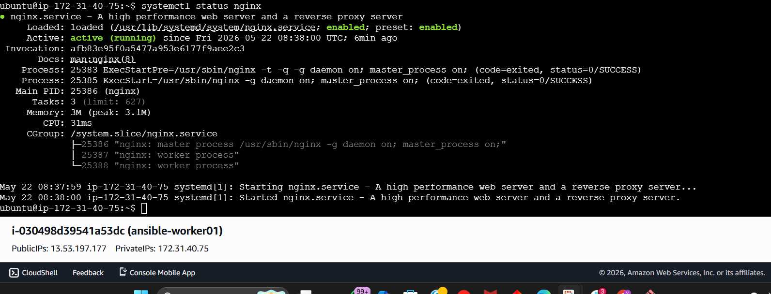
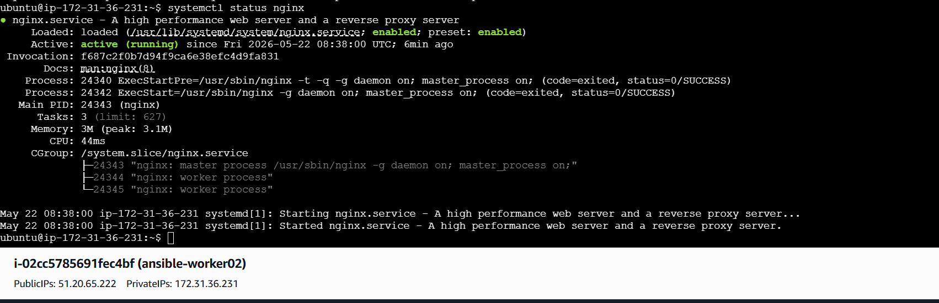
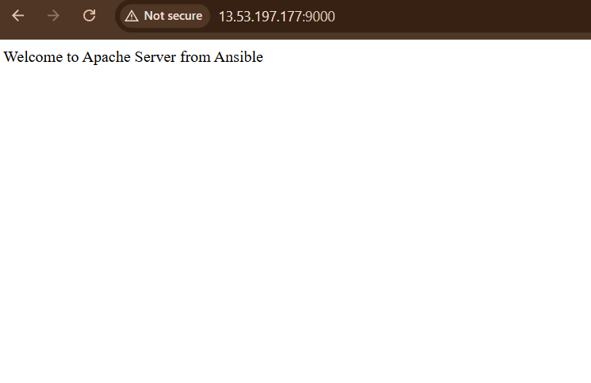
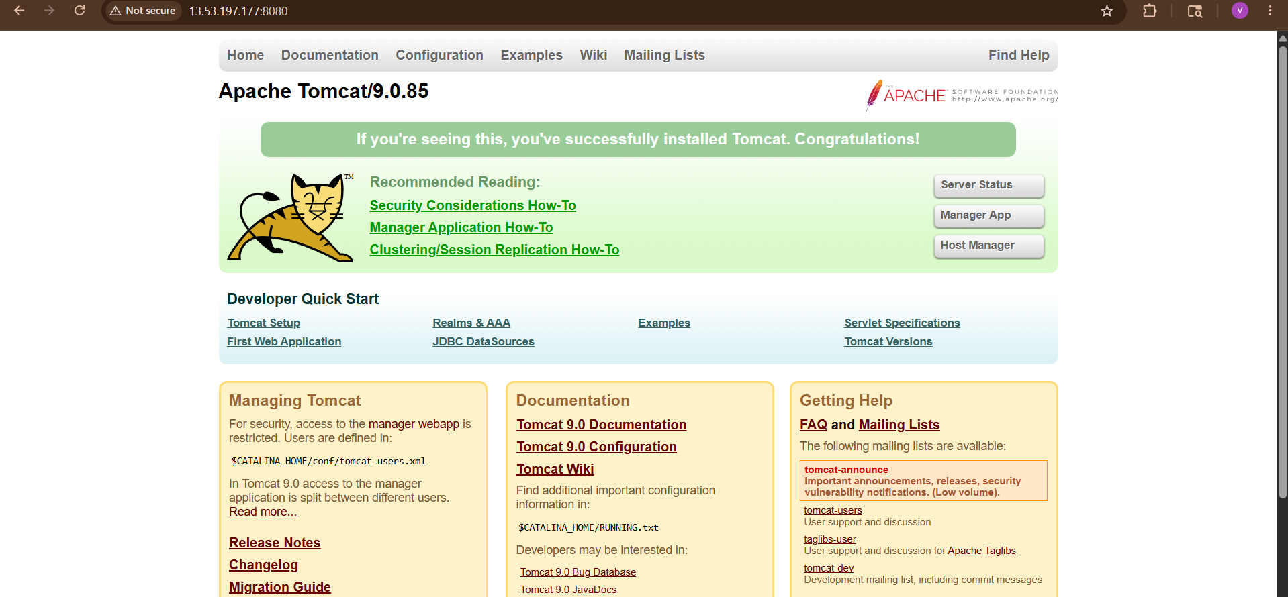
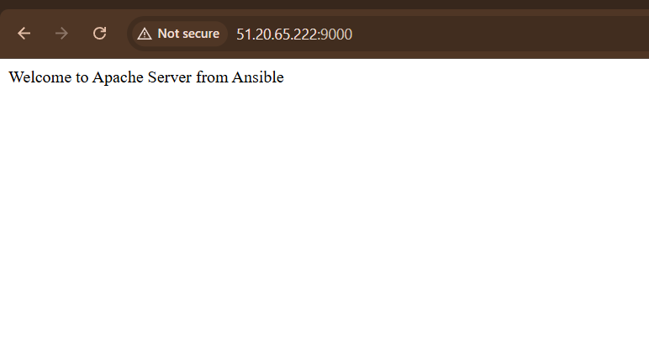
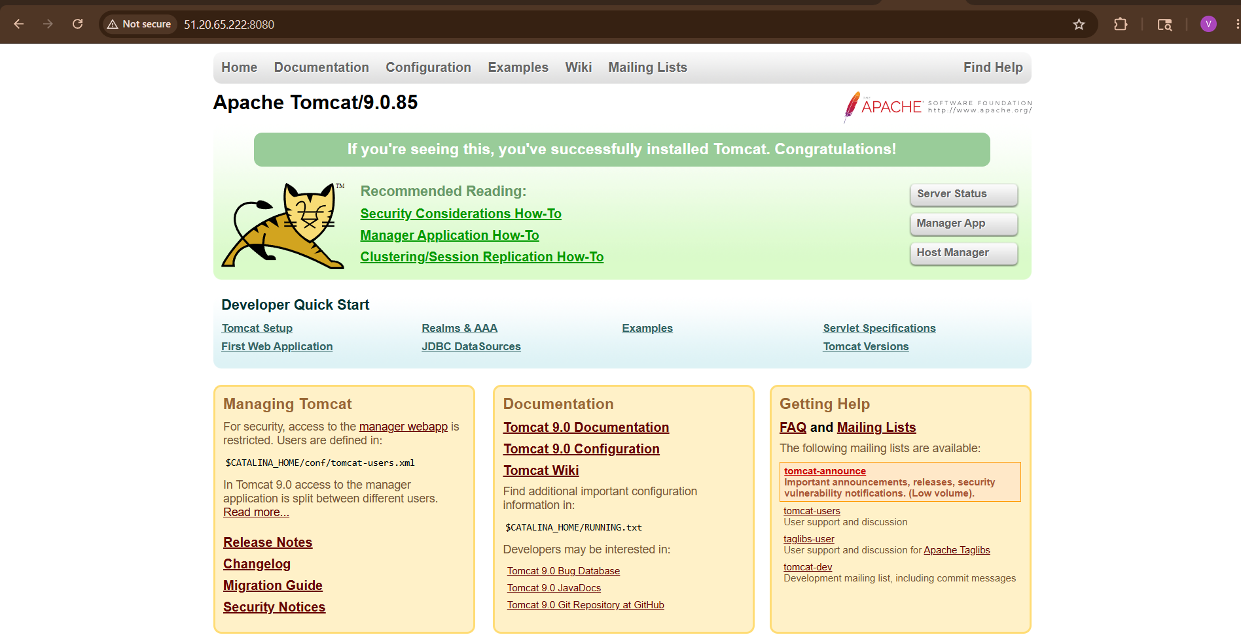22

Project Structure
webserver-playbook/
│
├── hosts
├── install-webservers.yml
└── vars/
└── packages.yml

Important Note
Apache and Nginx both use port 80 by default.
If both are running together, one service may fail due to port conflict.
To avoid conflict:
- Change Nginx port to 8080
OR
- Stop Apache before starting Nginx
Example:
sudo systemctl stop apache2

2) Ansible playbook to create 10 different directories with minimal code and directory names should be passed as variables.

Step 1: Create Project Directory
mkdir dir-playbook
cd dir-playbook
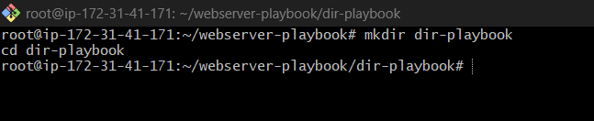

Step 2: Create Inventory File
Create a file called hosts
nano hosts
Add:
[webservers]
172.31.40.75
172.31.36.231
[webservers:vars]
ansible_user=ubuntu
ansible_ssh_private_key_file=/home/ubuntu/ansible.pem
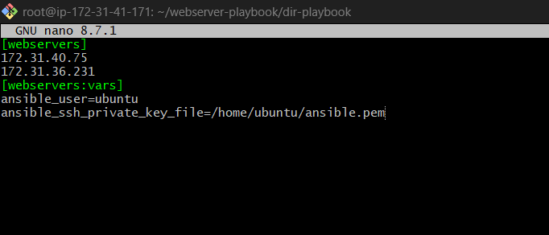
Replace:
- 172.31.40.75 → your worker node IP
- my-key.pem → your key file

Step 3: Create Variables File
Create a variables file:
nano dirs.yml
Add:
dir_names:
- /opt/dev
- /opt/test
- /opt/prod
- /opt/demo
- /opt/app1
- /opt/app2
- /opt/logs
- /opt/backup
- /opt/scripts
- /opt/config
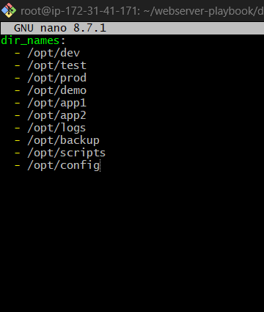

Step 4: Create Playbook
Create playbook file:
nano create-dirs.yml
Add this minimal code:
---
- name: Create multiple directories
hosts: webservers
become: yes
vars_files:
- dirs.yml
tasks:
- name: Create directories
file:
path: "{{ item }}"
state: directory
mode: '0755'
loop: "{{ dir_names }}"
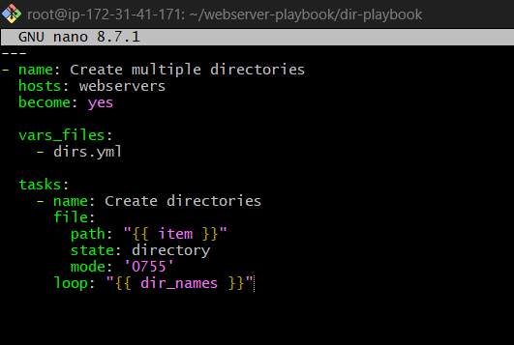

Step 5: Run the Playbook
ansible-playbook -i hosts create-dirs.yml
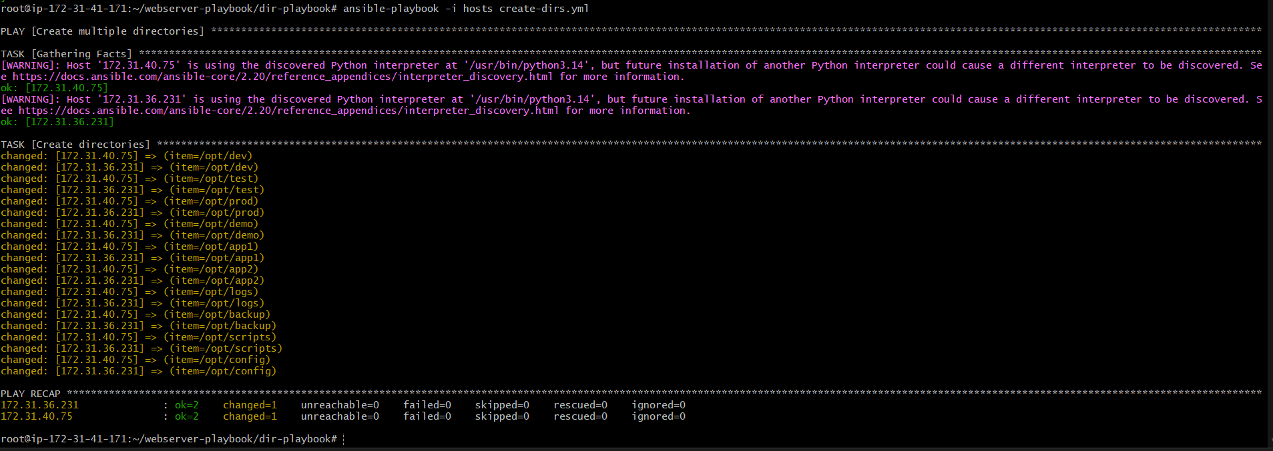
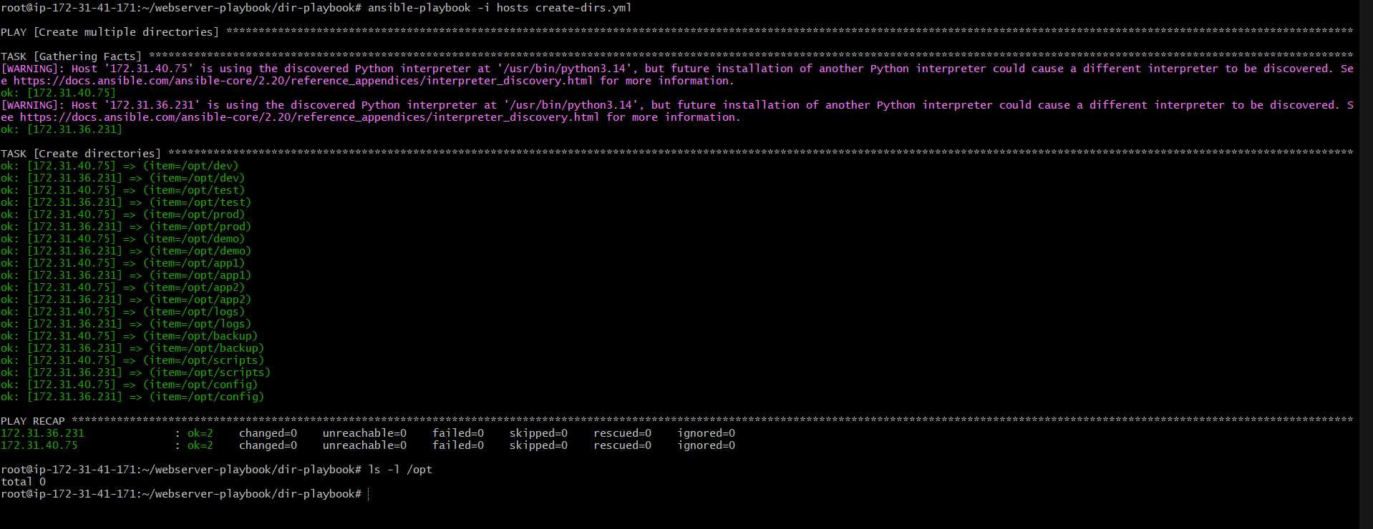

Step 6: Verify Directories
Login to Node server:
ssh -i my-key.pem ubuntu@172.31.40.75
Check:
ls -l /opt
You will see:
dev
test
prod
demo
app1
app2
logs
backup
scripts
config
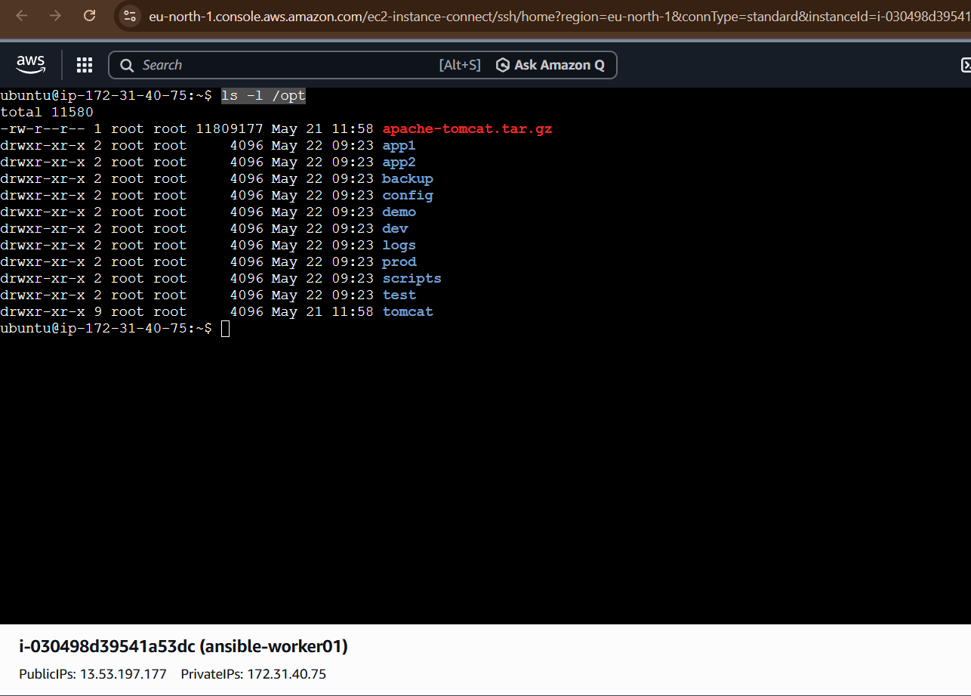


Explanation
vars_files
Loads variables from external YAML file.
vars_files:
- dirs.yml

loop
Loops through all directory names.
loop: "{{ dir_names }}"

file module
Used to create files/directories.
file:
path: "{{ item }}"
state: directory

3) Ansible playbook to copy ssh-keygen from master to worker nodes. Note: a)Provision new 3 ec2 machines, one master and two worker nodes. b)Create common user called ansadm and provide sudo priviliges on 3 ec2 instances. c)Create ssh-keygen in master and your playbook should copy the keygen making it password less authentication.

Ansible Playbook to Copy SSH Key from Master to Worker Nodes (Passwordless Authentication)
We will do this complete setup step by step.
Architecture
Server | Purpose
Master Node | Ansible Controller
Worker Node 1 | Managed Node
Worker Node 2 | Managed Node
Goal:
- Provision 3 EC2 instances
- Create common user ansadm
- Give sudo privileges
- Generate SSH key on master
- Copy SSH public key to worker nodes
- Enable passwordless authentication using Ansible

STEP 1: Provision 3 EC2 Instances on AWS
Create:
- 1 Master EC2
- 2 Worker EC2
Recommended:
- Ubuntu 24.04
- t2.micro
- Same VPC/Subnet/Security Group

STEP 2: Security Group Configuration
Allow:
Type | Port
SSH | 22
Source:
- Your IP
- Same security group

STEP 3: Install Ansible on Master Node
Login to Master:
ssh -i mykey.pem ubuntu@<MASTER-IP>
Update packages:
sudo apt update
Install Ansible:
sudo apt install ansible -y
Verify:
ansible –version
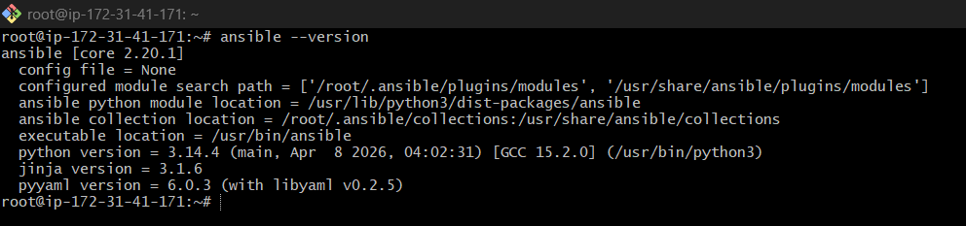

STEP 4: Create Common User on All 3 EC2 Instances
We will create:
- User: ansadm
- Passwordless sudo access

STEP 5: Create Inventory File
On Master node:
mkdir ansible-project
cd ansible-project
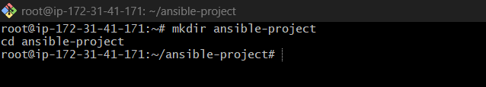
Create inventory:
nano hosts
Add:
[master]
<MASTER-IP>
[workers]
<WORKER1-IP>
<WORKER2-IP>
[all:vars]
ansible_user=ubuntu
ansible_ssh_private_key_file=/home/ubuntu/mykey.pem
Example:
[master]
172.31.10.10
[workers]
172.31.10.11
172.31.10.12
[all:vars]
ansible_user=ubuntu
ansible_ssh_private_key_file=/home/ubuntu/mykey.pem
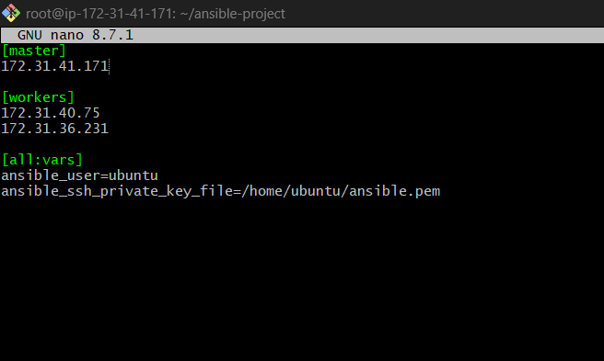

STEP 6: Create Playbook for User Creation
Create playbook:
nano create-user.yml
Add:
---
- name: Create common user on all servers
hosts: all
become: yes
tasks:
- name: Create ansadm user
user:
name: ansadm
shell: /bin/bash
create_home: yes
- name: Give sudo privilege
copy:
dest: /etc/sudoers.d/ansadm
content: "ansadm ALL=(ALL) NOPASSWD:ALL"
mode: '0440'
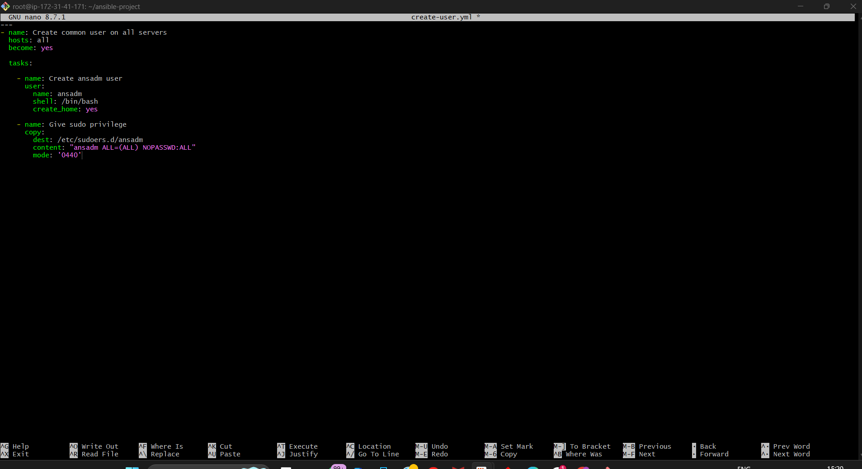

STEP 7: Run Playbook
Execute:
ansible-playbook -i hosts create-user.yml
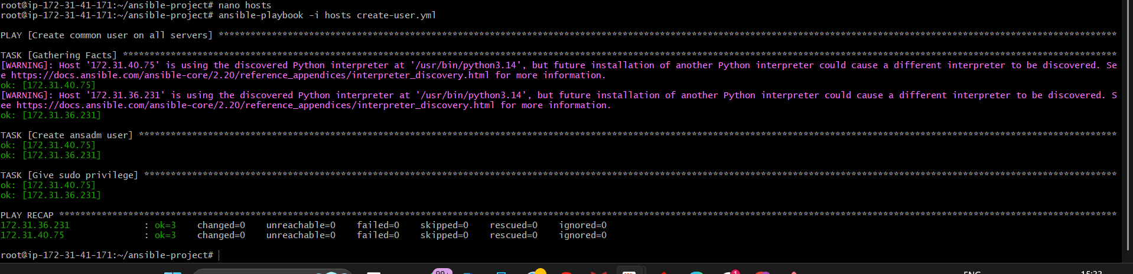
Verify:
ansible all -i hosts -m shell -a "id ansadm"

STEP 8: Generate SSH Key on Master Node
Switch to ansadm user:
sudo su – ansadm
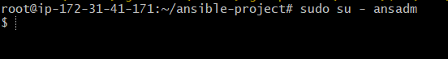
Generate SSH key:
ssh-keygen
Press Enter for all prompts.
Keys generated:
/home/ansadm/.ssh/id_rsa
/home/ansadm/.ssh/id_rsa.pub
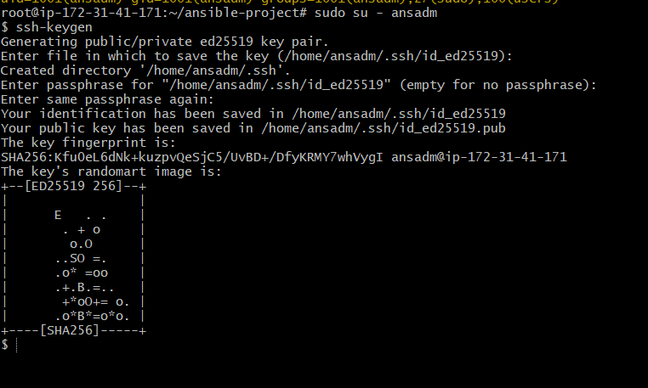

STEP 9: Create Playbook to Copy SSH Key
Now create playbook:
nano ssh-copy.yml
Add:
---
- name: Copy SSH key from master to workers
hosts: workers
become: yes
vars:
public_key: "{{ lookup('file', '/home/ansadm/.ssh/id_rsa.pub') }}"
tasks:
- name: Create .ssh directory
file:
path: /home/ansadm/.ssh
state: directory
owner: ansadm
group: ansadm
mode: '0700'
- name: Copy public key to authorized_keys
authorized_key:
user: ansadm
key: "{{ public_key }}"
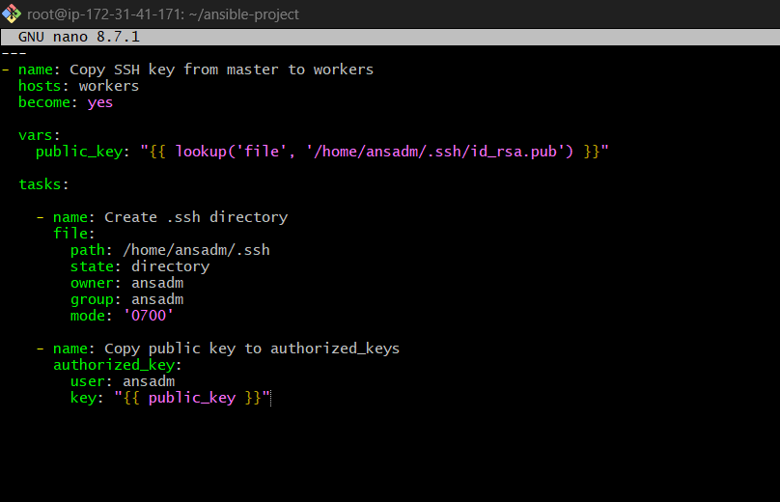

STEP 10: Run SSH Copy Playbook
Run:
ansible-playbook -i hosts ssh-copy.yml

STEP 11: Test Passwordless Authentication
From Master node:
sudo su – ansadm
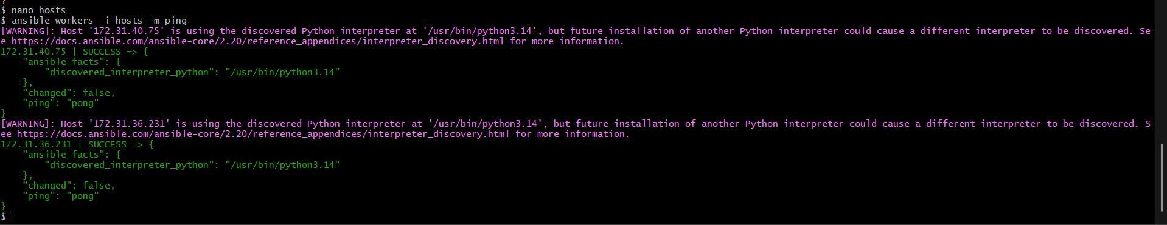
Try SSH:
ssh ansadm@<WORKER1-IP>
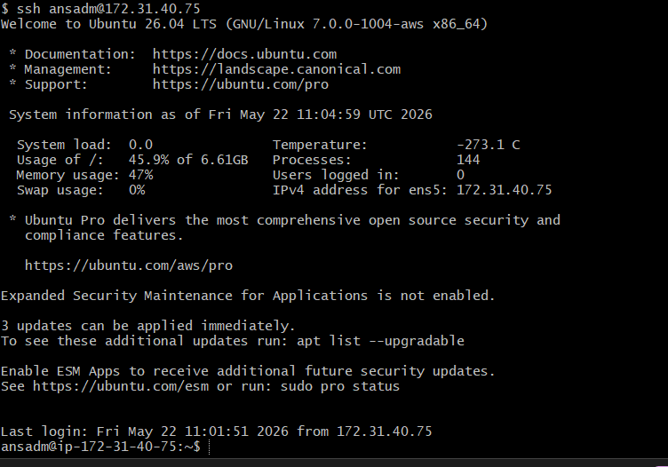
Then:
ssh ansadm@<WORKER2-IP>
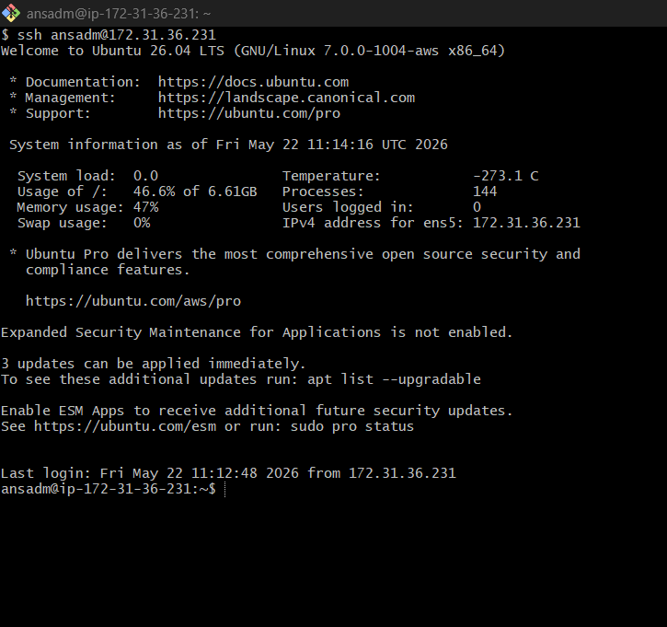
It should login without password.

STEP 12: Verify Using Ansible Ping
Create new inventory:
nano hosts-ansadm
Add:
[workers]
<WORKER1-IP>
<WORKER2-IP>
[workers:vars]
ansible_user=ansadm
ansible_ssh_private_key_file=/home/ansadm/.ssh/id_rsa
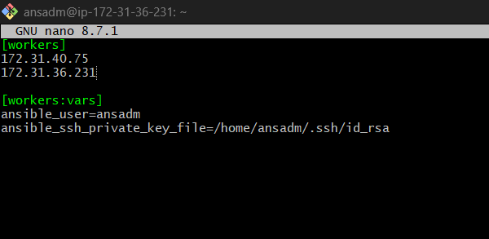
Now test:
ansible workers -i hosts-ansadm -m ping
Expected Output:
SUCCESS => {
"ping": "pong"
}
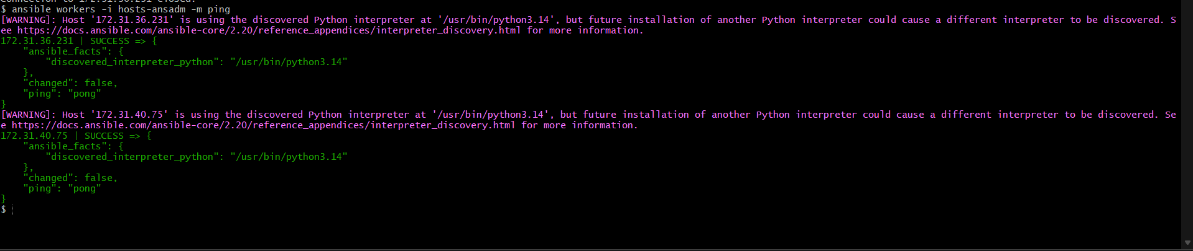

Final Project Structure
ansible-project/
│
├── hosts
├── hosts-ansadm
├── create-user.yml
└── ssh-copy.yml

Important Ansible Modules Used
Module | Purpose
user | Create users
copy | Copy sudoers file
file | Create .ssh directory
authorized_key | Copy SSH public key

Complete Flow Summary
- Provision 3 EC2 instances
- Install Ansible on master
- Create inventory
- Create common user ansadm
- Give sudo permissions
- Generate SSH key on master
- Copy public key to workers
- Enable passwordless SSH
- Verify using ping

4) Ansible playbook to inject ansible vault variables.

This is commonly used to hide:
- Passwords
- API keys
- Database credentials
- SSH secrets

Step 1: Create Project Structure
mkdir ansible-vault-demo
cd ansible-vault-demo
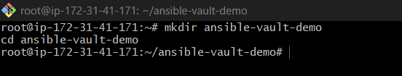
Create files:
touch hosts playbook.yml
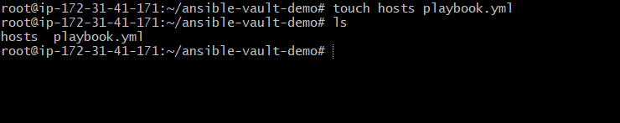
Directory structure:
ansible-vault-demo/
│── hosts
│── playbook.yml

Step 2: Create Inventory File
Edit hosts
[web]
172.31.40.75 ansible_user=ubuntu
Replace IP with your server IP.
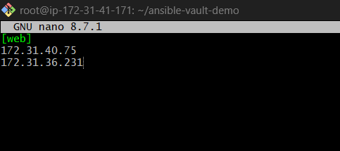

Step 3: Create Vault File
Create encrypted variable file:
ansible-vault create secrets.yml
It asks:
New Vault password:
Confirm New Vault password:
Enter password.
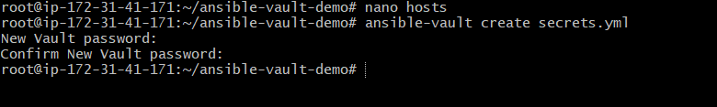
Then editor opens.
Add secret variables:
db_user: admin
db_password: MySecurePassword123
Save and exit.
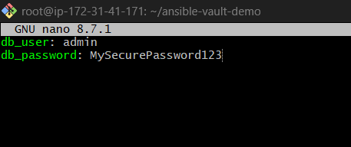

Step 4: Verify Vault File is Encrypted
cat secrets.yml
You’ll see:
$ANSIBLE_VAULT;1.1;AES256
6138643739623432...
Meaning file is encrypted.
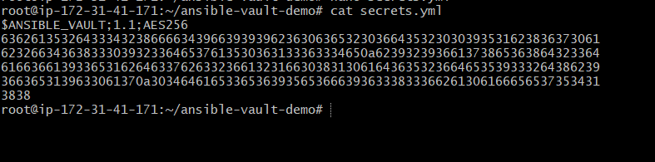

Step 5: Create Playbook
Edit playbook.yml
---
- name: Inject vault variables
hosts: web
become: yes
vars_files:
- secrets.yml
tasks:
- name: Create secret file
copy:
dest: /tmp/dbinfo.txt
content: |
Username: {{ db_user }}
Password: {{ db_password }}
- name: Print username
debug:
msg: "Database User is {{ db_user }}"
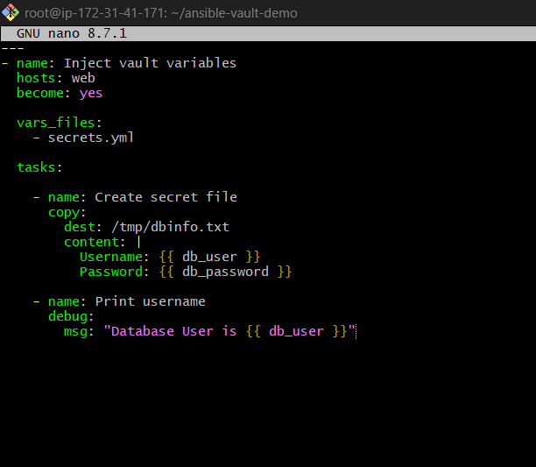

Step 6: Test Connectivity
ansible -i hosts web -m ping
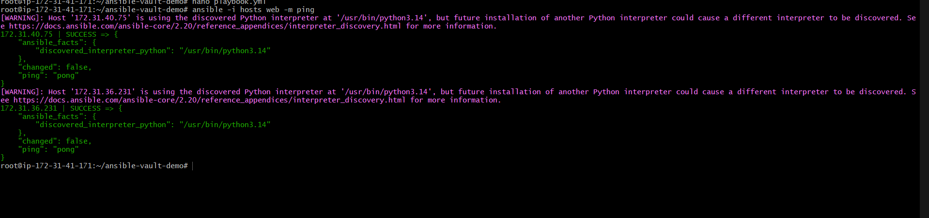

Step 7: Run Playbook Using Vault Password
ansible-playbook -i hosts playbook.yml --ask-vault-pass
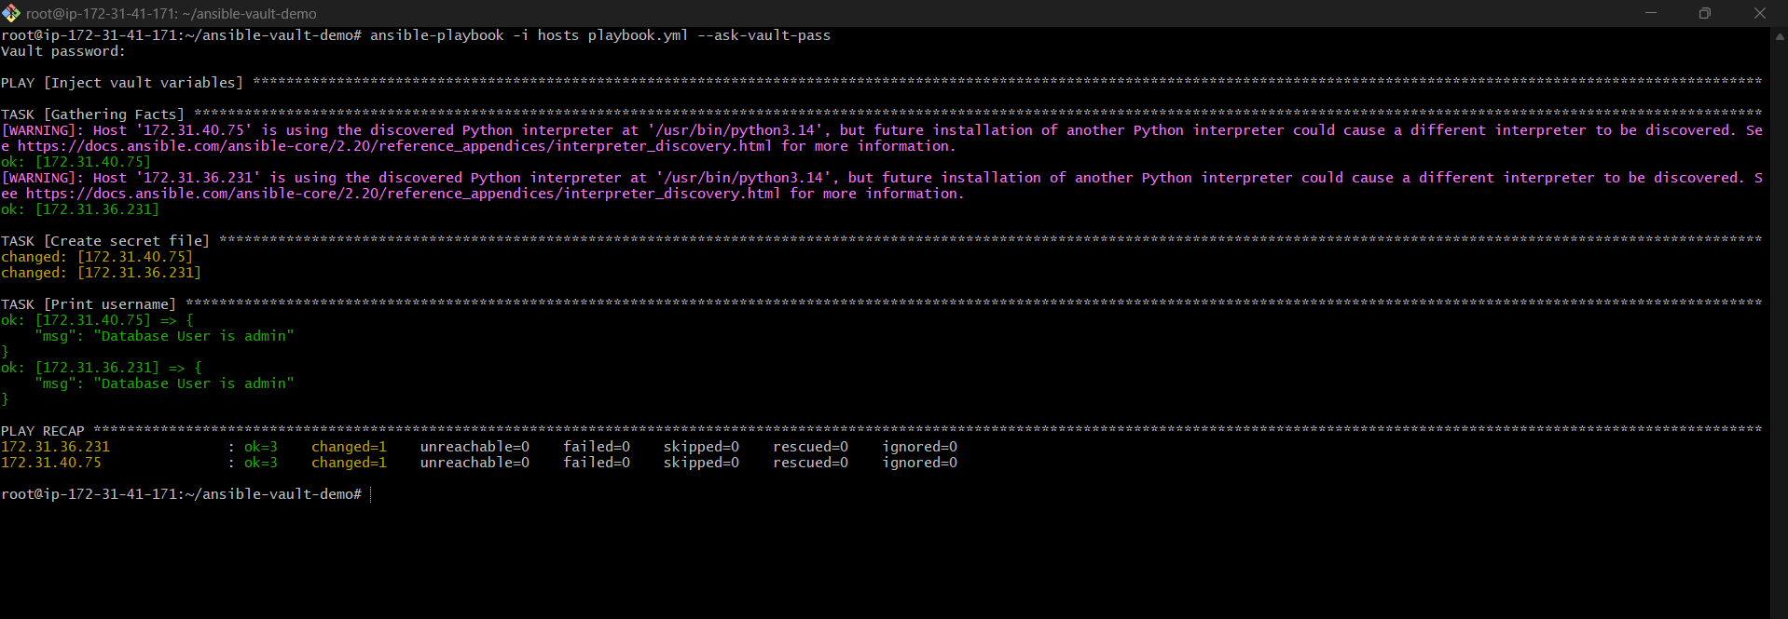
It asks:
Vault password:
Enter vault password.

Step 8: Verify on Remote Server
SSH into target server:
ssh ubuntu@172.31.40.75
Check file:
cat /tmp/dbinfo.txt
Output:
Username: admin
Password: MySecurePassword123
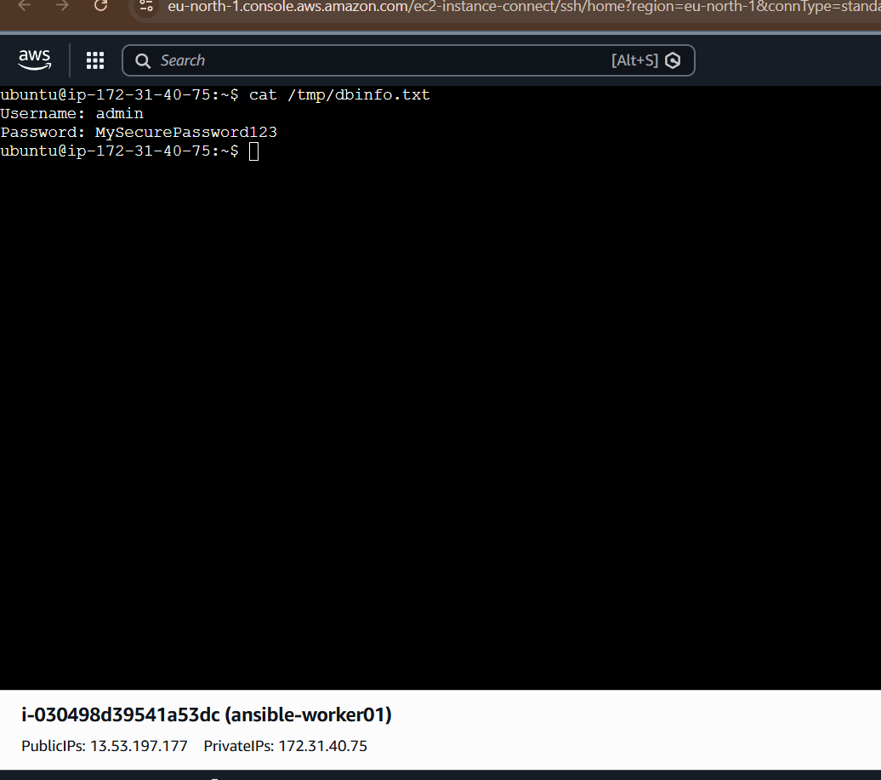
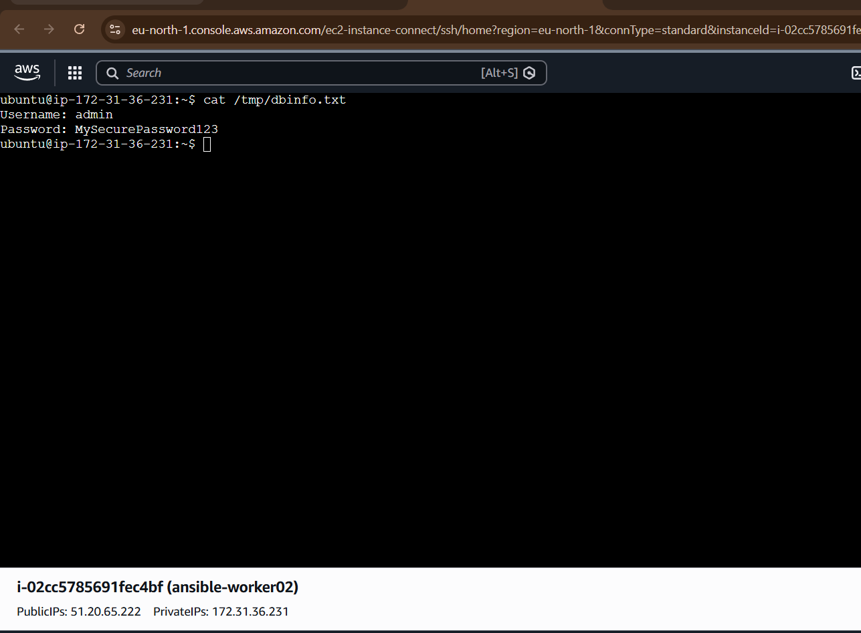

Step 9: Edit Vault Variables Later
To edit encrypted file:
ansible-vault edit secrets.yml
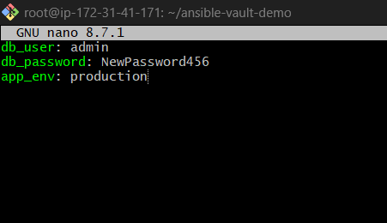


Step 10: Change Vault Password
ansible-vault rekey secrets.yml
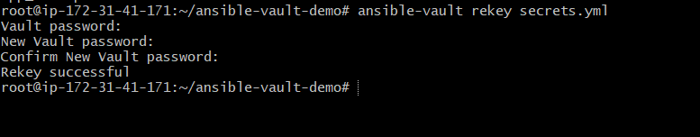

Step 11: Decrypt Vault File (Optional)
ansible-vault decrypt secrets.yml


Step 12: Encrypt Existing File
If normal YAML already exists:
ansible-vault encrypt secrets.yml
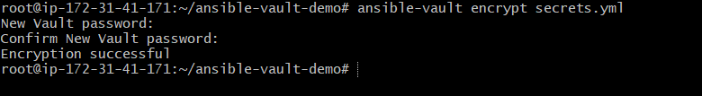

Production Best Practice (Recommended)
Instead of typing password every time:
Create password file:
echo "MyVaultPassword" > vault.pass
Secure it:
chmod 600 vault.pass
Run playbook:
ansible-playbook -i hosts playbook.yml --vault-password-file vault.pass

